

**Continuous Improvements in Communicating Monetary Policy**

Speech given by

Gertjan Vlieghe, External Monetary Policy Committee Member

Thomson Reuters London 12 July 2019

I would like to thank Rodrigo Guimarães, John Barrdear, James Benford, Ben Broadbent,

Richard Harrison, Olga Maizels, Francesca Monti, Kate Reinold, Michael Saunders, Martin Seneca, Silvana Tenreyro and Matt Waldron for comments and helpful suggestions.

# Introduction

Today I want to talk about how we communicate monetary policy at the Bank of England. I will first restate the case for why we do it at all. Next I will describe how a process of continuous improvement has led us to where we are today. Nevertheless, in my view there are further improvements that could be made. In particular, communicating more about the Monetary Policy Committee’s preferred future path of interest rates would be easier to understand than our current approach. I will explain the strengths and weaknesses of the current approach, and of my suggested improvement, referring both to the experience of other central banks and the evolution of consensus in the economics literature. I acknowledge, however, that this is a complex area, that change cannot happen overnight, and that various MPC members hold different points of view on the extent of change that is desirable. I wish to start a discussion, with a clear direction of travel, rather than propose an immediate change with specific details.

Global central banks have changed their outlook for policy significantly in recent months, and the UK outlook for monetary policy continues to be materially affected by Brexit uncertainty. You might ask whether it might not be better to talk about these forces, rather than to talk about communication strategy itself. I will discuss the current outlook for the economy and monetary policy as well. But I chose to talk about our communication strategy now, precisely because Brexit has amplified some of the difficulties we always face in communicating effectively with the public using our current approach.

The basic argument I want to make is very simple. Currently, the Monetary Policy Committee (MPC) publishes a forecast of what it thinks is likely to happen to growth and inflation given a path of interest rates determined by somebody else. That path of interest rates (the “market path”) sometimes results in a forecast that has inflation returning to target, sometimes not. If we want people to understand what we, the MPC, think is the necessary path of interest rates to achieve the inflation target, why not just tell them? Why complicate matters by telling them that if we followed some *other* path of interest rates, it may *not* result in achieving the inflation target? Yet our current approach to communications is precisely that. We communicate about what we think we may do, by showing you a forecast of what will happen if we do something else.

Before diving into the details of the argument I want to stress that a far bigger challenge to monetary policy is that the future is uncertain, and my suggested communications improvement will not change that. Today’s preferred path of interest rates will change tomorrow, if the economy turns out differently from what we expected. But I am arguing that we can achieve a modest improvement in the understanding that businesses, households and financial markets have of what our objectives are, and what we think we need to do to meet those objectives. Over time, that improved understanding should make it slightly easier for us to meet our objectives in the first place.

# Restating the case for monetary policy communication

Economic agents are forward-looking. They may or may not be fully rational, but when they make decisions, households, businesses and financial market participants think about the future. So when forming decisions about how much to buy and sell and at what price, economic agents take into account not just what the setting of monetary policy is today, but what it will be in the future. It is therefore not just today’s interest rates that matter for monetary policy, but the entire expected future path of interest rates as well.

The objective of monetary policy communication is to increase transparency, i.e. to ensure that economic agents understand what it is that the central bank is trying to achieve, and what policy settings are likely to be required to achieve it. 1 In the UK, the MPC’s objective is to achieve 2% CPI inflation, while avoiding undesirable volatility in output due to short-term trade-offs between inflation and output.

The better economic agents understand that interest rates will always be set to achieve this objective, the easier it is for the MPC to achieve the objective. For example, if inflation falls short of the target because demand growth is too weak, economic agents will understand that monetary policy will aim to stimulate demand growth until inflation reaches the target. Economic agents will expect a monetary stimulus, and will expect it to remain in place for as long as is necessary to bring inflation back to target. The resulting fall in future interest rates will create a more powerful stimulus than a fall in current short-term interest rates alone. In turn, that will mean that longer-term inflation expectations are stable even when actual inflation deviates from the target. This mechanism is always important, and even more so when interest rates are close to their effective lower bound.2

A second motivation for transparency is that it improves accountability. It is difficult to hold a central bank accountable for its actions when the central bank is not fully transparent about how it comes to its monetary policy decisions and what it is trying to achieve with monetary policy.

# How does the MPC communicate now, and how did we get here?

Unless you have been a central bank observer for many decades, or a student of the history of central bank communication, it will probably surprise you to learn that central banks communicated very little in the past. Former central bankers used to pride themselves on being opaque about their actions and their intentions. “Mystique” was considered a desirable attribute (see Haldane (2017)). The Federal Reserve did not even

1 Swanson (2006) shows that US financial markets and private sector forecasters have become better at forecasting the policy rate since the 1980s, as transparency increased. Ehrmann et al (2012) find that central bank transparency lowers disagreement among professional forecasters, so there is less uncertainty about future monetary policy.

2There may be times when the lower bound is binding to such an extent that the central bank may wish to specify additional forward guidance over and above the normal, “all-weather” communication that I am advocating in my speech today. Calendar-based forward guidance in Canada and the US in 2009-10 and 2011-12 were examples of this, as well as forward guidance that was linked to the evolution of particular economic variables, as used in the US and UK in 2012-13 and 2013. Both my all-weather communication and the forward guidance that has been used so far falls into the “Delphic” rather than “Odyssean” category: in other words, it only seeks to clarify future its own forecasts, it does not seek to commit policymakers to a path that they might in the future want to deviate from.

announce by how much it had changed interest rates until 1994. The UK did not have regularly scheduled monetary policy meetings until 1992. Before that, interest rates could change at any time.

There has been a steady evolution in central bank communications. Focusing on the UK, a regular schedule of policy meetings was announced in 1992, along with a formal target for inflation of 1%-4% on the RPIX measure. In 1993, the first quarterly Inflation Report was published. In 1997, the inflation target was set at 2.5% RPIX inflation (later changed to 2% CPI inflation in 2003) and the Bank of England was made operationally independent, so that it was now communicating about its own interest rate decisions, rather than about the interest rate decisions of the government.

Alongside operational independence came a range of new communications. There were statements to explain the brief motivation for interest rate changes, and Minutes to explain the detailed discussions and votes of the newly created nine-member Monetary Policy Committee.

I want to go into more detail on the forecasts contained in the Inflation Report. Even the very first Inflation Report in 1993, before operational independence, already contained a forecast for inflation. It was already a fan chart of sorts,3 even in those days, meaning it illustrated the uncertainty around the central projection. It lacked the graduated colour bands, which were introduced in 1996. And, relevant to my discussion today, it was a forecast of inflation made on the assumption of interest rates remaining constant at whatever the prevailing level was when the report was produced.

If the forecast based on constant interest rates showed medium-term inflation rising above the central point of the target, that was generally thought to imply the need for a tightening of policy, although by an unspecified amount and at an unspecified time in the future. Occasionally, the implication of the forecast was spelled out qualitatively:

“… on the present evidence, there is still likely to be a need for some further moderate tightening of policy in the months ahead” (Inflation Report, May 1997)

“…if sterling does not decline, then, depending on other developments in the economy, further easing of monetary policy might be needed to prevent undershooting of the inflation target” (Inflation Report, May 1999)

From August 2004, the MPC switched the focus from the constant rate based projection to the market path based projection.4

3 It was called a “trumpet chart” in those days.

4 The market path based projection was already included in the Inflation Report from February 1998, as an “alternative projection” at the back of the Report. From August 2004, the emphasis switched to the market path based projection, and it was the constant rate forecast that was relegated to the back of the Report.

One important reason for the switch was that, in 2003 and early 2004, interest rates had fallen some way below what was considered neutral at the time. A forecast that was conditioned on interest rates permanently staying at such low levels was considered “less plausible” and therefore “a less helpful guide to the outlook” (IR August 2004 p42). The problem was exacerbated by the fact that the MPC also extended its forecast horizon from two years to three years: under the assumption of constant interest rates inflation moved further and further away from the target at the longer three-year forecast horizon. Switching to a market interest rate assumption instead resulted in inflation settling around the target at the forecast horizon. It was acknowledged that this would not always be the case, but was nevertheless thought to be a “more helpful benchmark” (p42) than constant rate assumption.

Over the subsequent 15 years, MPC communications have continued to evolve by providing forecasts of a much wider range of variables than just growth and inflation, and also by providing more details in other ways about the likely future path of interest rates (see also Carney (2019a)). Let me highlight three important recent innovations in this area. First, the MPC introduced language in its Monetary Policy Statement to describe some aspects of the future path of interest rates that it thinks is most likely: since February 2014, the outlook for interest rates has been described as “….an ongoing tightening of monetary policy over the forecast period, at a *gradual* pace and to a *limited* extent, would be appropriate…”. Second, the MPC has introduced language in its Monetary Policy Statement to describe its policy reaction function in case the main assumption of a smooth Brexit does not hold: “the appropriate path of monetary policy will depend on the balance of […] the effects on demand, supply and the exchange rate”. Third, the MPC has published in the August 2018 Inflation Report its view, to be updated periodically, on R*, the level of interest rates that is expected to prevail once shorter-term headwinds or tailwinds to the economy have dissipated. But the key concept of a quantitative forecast of the likely paths of growth and inflation based on market interest rates has, over the past 15 years, remained unchanged.

# Should we communicate even more about the future path of interest rates?

As I have shown, the MPC has always provided some information about the likely future path of interest rates, both qualitatively, with its choice of words, as well as quantitatively, via the forecast. And we have started to explore how the path of interest rates may change if the economy turns out differently from our central projection. But I think there would be gains from being even more explicit.

Currently, if the forecast based on market interest rates shows inflation rising above the target, that *might* suggest that the MPC collectively thinks interest rates need to rise faster than the market path. I say “*might*”, because, in reality, the inference that can be drawn from the forecast is not nearly that straightforward, and I will now turn to what I see are some of the challenges involved in communicating about the future path of interest rates *implicitly*, as we do now, via a forecast based on the market path of interest rates.

First, as my colleague Ben Broadbent explained in a recent speech,5 it is not possible to back out a unique MPC-desired path for interest rates simply by observing how far the inflation forecast is above or below target at the end of the forecast period. Such a forecast can be consistent with interest rates rising then falling, or falling then rising, and with varying magnitude and timing. Woodford (2013) makes a similar, but even more general point: “the procedure [of a forecast based on the market path] is incompletely specified… the published projections cannot be expected to shape private decision-makers’ forecasts of the economy’s evolution”. We, the MPC, are asking outside observers to solve a complex reverse-engineering problem that cannot be uniquely solved*.*

Second, it is not clear – without further information that is not currently contained in the forecast itself – whether an overshoot at the end of the forecast horizon is an undesirable overshoot that requires more policy tightening, or instead is a desired overshoot that balances the short-term trade-off between growth and inflation.6

For both of these reasons, the forecast provides insufficient information by itself, and this is why the MPC needs to and does provide additional language on the nature of the preferred path of interest rates, and the extent to which some deviation of inflation from target can be tolerated temporarily to balance the short-term growth-inflation trade-off.

Third, the market path can move for a number of reasons that cause the forecast to move in counterintuitive ways, greatly complicating the policy message. The market forward path used in the MPC forecast is not the same as “market participants’ expectations of future interest rates”, because the forward rates contain risk premia, which vary over time but are not directly observable. This leads to various commentators saying at times that the MPC forecast implies market participants are wrong, even though the forecast may in fact be entirely consistent with market participants’ true expectations.

Fourth, and particularly relevant at the moment, market participants may not take the same view of the economy as the MPC does, in which case it would be entirely logical that they take a different view on the likely path of interest rates. In the most recent MPC forecast in May, the forecast explicitly does not take into account the risk of a no deal Brexit, since it assumes a smooth adjustment to an average of a range of outcomes, consistent with the government’s stated objectives. But market participants do in fact take the risk of a no deal Brexit into account. So we are showing a forecast of GDP and inflation conditioned on a smooth Brexit assumption, based on an interest rate path (and various other asset prices) that also factors in no-deal risk. This potential inconsistency between MPC assumptions for growth and inflation, and market assumptions for interest rates is always present to some extent, but is particularly large at the moment.

Consider the following highly simplified example. Suppose that, over some hypothetical horizon, market

5 See Broadbent (2015).

6 For example, after the depreciation of sterling following the 2016 referendum, the MPC said it would tolerate an overshoot in inflation to some extent, to avoid an undesirable short-term rise in unemployment that was anticipated if policy had been tighter. See the November 2016 Inflation Report.

participants perceive there to be a 1/3 probability of a no deal scenario, and suppose market participants think interest rates might be cut to zero in such a case, but to remain unchanged otherwise. That would lead to an average pricing a full 25bp rate cut, even if a rate cut was not the most likely perceived scenario.7 Fifth, the market path of interest rates moves all the time, including during the period when the MPC is

agreeing the forecast. We end up spending considerable time adjusting the forecast to ensure it still conveys the message we want it to convey, even on occasions when we think the underlying picture of the economy has changed less than market pricing of interest rates. I do not believe these adjustments represent an optimal use of our time.

I would summarise these five problems with the current approach as follows: first, our current approach is too complex and inefficient, and, second, contains inconsistencies.

It is too complex, because it requires outside observers to perform a complicated reverse engineering problem which does not even have a unique solution: we ask outside observers to work out the paths for growth, inflation and interest rates that the MPC prefers, by showing them paths for growth, inflation and interest rates that the MPC does not prefer. And we know that this provides outside observes with insufficient information to solve the problem.

It contains inconsistencies, because on occasion the forecast shows a path of inflation that is not consistent with the MPC’s mandate. It also contains a different kind of inconsistency, namely it mixes MPC assumptions about certain aspects of the economy, with market participants’ assumptions about interest rates and risk premia, and these do not necessarily combine to provide a coherent message on the outlook.

A more straightforward approach, in my view, would be to publish a forecast based on the MPC’s *preferred* path of policy, rather than on the market path. The preferred path for policy would be the path of interest rates that the MPC, in its best collective view, believes is consistent with returning inflation to target over an appropriate horizon. That would require no reverse engineering by outside observers, would suffer from fewer8 inconsistencies, and would give a clear message about how quickly the MPC aims to return inflation to target, and what changes in interest rates it believes will be required to achieve that.

We might still show an alternative forecast based on some other path, in order to show what difference it would make, or to discuss salient alternative scenarios, as this would allow outside observers to better understand the MPC’s policy preferences and views of the transmission mechanism. But the main quantitative messages about the outlook for the economy and monetary policy would be contained in this new forecast based on the preferred path of policy.

7 In this stylised example, without any risk premia, market interest rate would be (1/3)*0%+(2/3)*0.75%=0.5%. The most likely outcome would be 0.75%, with a 2/3 probability.

8 I say fewer inconsistencies, rather than no inconsistencies, because other asset prices such as the exchange rate, equity prices and credit spreads might still incorporate assumptions about the economic outlook that are inconsistent with the MPC’s assumptions, as is the case right now with asset prices that incorporate some Brexit scenarios that are not in the MPC’s forecast.

There are many ways of constructing and communicating such a forecast, with varying degrees of precision. I do not want to be prescriptive at this stage concerning the details of the implementation. I think agreeing on the conceptual point is far more important. But, to fix ideas, one workable suggestion would be for the MPC to publish its views for the policy rate at the end of years one, two and three of the forecast period, similar to the way the MPC currently communicates some of its key judgements in the Inflation Report. It would be important to communicate the degree of uncertainty around this path. The major advantages of communicating about the policy path at yearly horizons, rather than per quarter or per policy meeting, are twofold. First, it avoids giving an unwarranted sense of precision over what is an inherently difficult judgement subject to significant uncertainty. Second, by avoiding communicating about the very near term outlook about policy, the MPC preserves ample flexibility to respond to near term data fluctuations as they arise. I would not want to be in a situation where the MPC, in effect, feels it is already committing not just to this meeting’s interest rate, but next meeting’s interest rate as well.

# What has been the experience of other central banks?

The idea of publishing the MPC’s preferred path of interest rates is not new. Several other central banks have already implemented versions of this.

The central banks of New Zealand, Norway, Sweden, Israel, South Africa, Czech Republic and the

United States all publish forecasts of the economy that are based on the central bank’s own published view of the likely path of interest rates.9 The appendix shows examples of the way each institution has chosen to communicate about its future interest rate path.

This global communications trend is consistent with the evolving consensus10 that it is important for a central bank to be as transparent as possible, which improves both the effectiveness of policy and the ability to hold unelected central bank officials accountable for their actions. Given this consensus, I would argue that the logical consequence is that it would be an improvement to communicate clearly about how the policy instruments are likely to be set in order to achieve the central bank’s objectives. 11 It is difficult to argue that only communicating implicitly about this, as we currently do, is better from a transparency point of view.

The stated reasons of these central banks for having made the change in their communication strategy is to

* Increase transparency and accountability
* Avoid the difficulties associated with constant rate or market rate based forecasts, such as lack of internal consistency, and the challenge of having to publish forecasts that are not consistent with the

9 Not all central banks publish a committee forecast. The central bank of Israel and the Czech Republic publish staff forecasts of the economy and interest rates, while New Zealand, Norway and Sweden publish a committee forecast of interest rates. Iceland publishes macroeconomic forecasts based on a model based interest rate path (a published forward looking Taylor rule), though they do not publish the interest rate path itself.

10 See Svensson (2010a,b).

11 Within the so-called New Keynesian class of models that includes central banks’ main models, Woodford (2013) shows that a forecast conditioned on market or constant rates is inferior to being explicit about the full path of interest rates that meets the central bank’s objectives.

price stability mandate (when constant or market rate paths are far from the central bank’s own view of the appropriate path)

* Sending a clear message to households, firms and market participants, to help shape their expectations of the future path of interest rates.

These central banks have generally reported being satisfied with having made the change,12 in terms of clearer communication, and improved internal consistency. Research in Norway and Sweden shows that changes in published interest rate paths influence market participants’ expectations, as well as those of households.13 There is some tentative evidence that the publication of interest rate paths has improved outside observers’ short term policy rate forecasts in Sweden and Norway.14

Moreover, the Swedish central bank reported that the quality of its own internal deliberations and discussions with staff had improved, and that discussion of monetary policy by external observers had become “less speculative”.15 The Reserve Bank of New Zealand noted that a forecast that explains how inflation will be returned to target, rather than one that shows inflation not returning to target because of an inconsistent rate path, was considered more informative. The central bank of Norway thought the change had made it “easier to interpret, evaluate and communicate our view of the economy”.16

A separate comment is in order regarding the experience in the US. The US has a somewhat different approach in that it publishes an interest rate forecast (“dot”) for each member of the FOMC, rather than the collective committee view that I favour. Publishing forecasts of interest rates has found only qualified support at the Fed, and at times outright frustration, e.g. Powell (2019): “Unfortunately, at times the dot plot has distracted attention from the more important topic of how the FOMC will react to unexpected economic developments. In times of high uncertainty, the median dot might best be thought of as the *least unlikely* outcome”. However, it must be stressed that the US approach was a compromise. The initial desired approach was, in fact, to publish a collective FOMC view, but it was found too difficult to agree on given the large size and federated nature of the committee, including the fact that non-voting or “alternate” members also contribute to the assessment of the economic and policy outlook. This is discussed in more detail in,

e.g. Bernanke (2016) and Powell (2016). A frequent criticism of the dots is that they are not connected, i.e. they do not identify which interest rate forecast corresponds to which growth or inflation forecast, therefore missing out some key information on why some members have higher or lower rate path preferences. Another criticism is that they focus too much on the diversity of views (the “cacophony problem”), and not enough on the uncertainty about the future path due to uncertainty about the evolution of the economy (see Kohn (2018), Faust (2016) and also Powell (2019) as illustrated by his quote). Many of the critics, both

12 See the assessment of the RBNZ at [https://www.rbnz.govt.nz/monetary-policy/about-monetary-policy/independent-review-of-the-](https://www.rbnz.govt.nz/monetary-policy/about-monetary-policy/independent-review-of-the-operation-of-monetary-policy-2/publication-of-projections) [operation-of-monetary-policy-2/publication-of-projections,](https://www.rbnz.govt.nz/monetary-policy/about-monetary-policy/independent-review-of-the-operation-of-monetary-policy-2/publication-of-projections) Olsen (2014) for the Norwegian experience and Riksbank (2017) for the Swedish experience.

13 See Brubakk et al (2017), Ahl (2017) and Iversen and Tysklind (2017).

14 See Kool and Thornton (2012), Beechey and Osterholm (2012) and Olsen (2014).

15 See Riksbank (2017) page 9.

16 See Olsen (2014).

internal and external, have also suggested ways of improving the Fed’s approach, for example by connecting the dots and by constructing uncertainty bands around the dots. But, to reiterate, I am advocating a different approach from that taken by the Fed.

# What are the arguments against publishing a preferred rate path?

If one designed a forecast and communication framework from scratch today, it would, in my view, not look like what the MPC chose many years ago, given what we have learned over the years about the inconsistencies and complexities that it creates. Instead, the MPC’s approach has to be understood as the product of a continuous evolution since the very first Inflation Report in 1993, where weaknesses and vulnerabilities were exposed with experience, and then addressed with gradual improvements.

Nevertheless, the reality is that we are not designing the framework from scratch. The current framework has been in place for a long time, some argue it is well understood despite its known flaws, and there is clearly a risk in changing it. I also want to emphasise that while my suggested change is simple in its logic, it will nevertheless require a substantial overhaul of the forecast process in order to implement it. This is not a change that can or should be made overnight.

Moreover, some argue that publishing a preferred path can bring problems of its own. I address these arguments below.

* 1. A forecast could be misinterpreted as a promise

If the MPC were to publish its own view of the most likely path of interest rates, outside observers might misinterpret this as a promise rather than a forecast, especially if the MPC were to include details of its preferred rate path in the near future, e.g. the next policy meeting or two, which I am not suggesting we do. The central bank is fully in control of interest rates, so if interest rates deviate from the previously announced forecast, this might be seen as reneging on a promise, and could hurt central bank credibility.

In principle, this is a valid concern. However, several central banks now have experience with publishing a forecast of their own rate path, and none of the central banks that have made the change, have reported this type of systematic misinterpretation between forecasts and promises (see Olsen (2014), McDermott (2016), Riksbank (2017), Powell (2016)). They have taken active steps to ensure public understanding of the uncertain nature of the interest rate forecasts, often by publishing uncertainty bands or fan charts rather than only a central path, and always by emphasising the uncertain nature of the path and it data-dependence

* 1. The central bank might be reluctant to change its forecast

The concern here is that a forecast of an interest rate path, once made, will remain in place for too long. There is a risk of becoming less data-dependent.

However, looking at other central banks, it is clear that the interest rate forecasts are changed at nearly every meeting, so there appears to be no reluctance to change them (see Alsterlind (2017)).17

* 1. Published interest rate forecasts may prove to be wrong

The future is uncertain. Given that there will be unanticipated changes in the economic outlook, it is logical to have unanticipated changes in the interest rate forecast as well. In any case, the MPC is already changing its *implicit* view of the future path of interest rate all the time. The risk is not that the MPC would change its mind more, it would just be more visible. But given the added clarity that the forecast would bring, I do not see why this would be a problem. The MPC already changes its growth and inflation outlook at every Inflation Report. It would, under the new system, simply explain what the consequences of that changed growth and inflation outlook would be for the likely path of interest rates, as well as providing an outlook for growth and inflation that was consistent, by construction, with what it intends to do with interest rates.

* 1. There might be a gap between the market rate path and the MPC forecast of interest rates

Indeed. There is a gap now, it is just implicit rather than explicit. If the gap were made explicit, commentators could have a more focused discussion on why there was a gap. Is it because the market path of rates does not reflect the market’s expectation of the most likely path of rates, due to risk premia? Is it because the market has a different view of the economy, but the same view of the reaction function? Or is it because the market has the same view of the economy, but a different reaction function (e.g. a different view of R*).

Surely it would be better to be able to discuss why the gap was there, so that everyone could form a view as to what type of data news or events would eventually close the gap?

17 A recent paper by Mirkov and Natvik (2016) looks at this problem more formally, and investigates whether previous forecasts of policy decisions have explanatory power for current policy decisions, over and above data on the state of the economy. The finding is that, in the case of the central bank of Norway and the Reserve Bank of New Zealand, there is some evidence that at a one-quarter horizon, these central banks put some weight on their previous forecast. At horizons of more than one quarter, previous forecasts have no explanatory power at all.

However, the interpretation of these results is complex: it is only suggestive of a lack of data dependence if one has a really comprehensive model of what the “right” interest rate is, given the data on the state of the economy. Failing that, the previous forecast of the interest rate path may just contain useful information about the central bank’s judgement on the state of the economy and the outlook that is not perfectly captured in other data.

Moreover, the problem is easily fixed by not publishing a quarter-ahead forecast of the interest rate, but instead, as I suggest, only publishing interest rates forecasts for, for example, one, two and three years ahead.

* 1. The Committee might not be able to agree on a rate path

I offer three counters to this argument. First, other committees, such as the Swedish and Norwegian central bank, *have* been able to agree a rate path, and have not reported any great difficulties doing so. The 19 members and non-voting members of the FOMC are a notable exception, as mentioned earlier.

Second, the logical steps needed to agree an interest rate path are not fundamentally different from the logical steps needed to agree a path for growth, inflation, slack, productivity, wages, etc, all of which the MPC currently already manages to agree on. We do not agree exactly, but we come to a best collective judgement. All these paths are already the product of economic models, which are imperfect, to which significant judgement is added. The requirement for agreement and precision is no higher for an interest rate path than for any other variable, especially in the case of an interest rate path at yearly horizons only, which is less detailed than some of the other forecasts we already publish.

Third, even if it turns out to be somewhat more difficult to agree a rate path, surely the discussion surrounding it would be a really useful discussion for the MPC to have. This is actually one of the main benefits I see in moving to preferred path based forecasts, which appears to be supported by the experience of other central banks that have made the change. Some members might prefer a lower path, some a higher path. Why is that? If they have already agreed on a path for growth (and slack) and inflation, it must be because they have a different view of the transmission mechanism, hence of the reaction function. Fleshing out these differences of view would, in my opinion, be a high quality discussion that would benefit the MPC as a whole. The only reason why it might be discussed more in the future than it is today, is because today the MPC members’ views about the future path of rates are implicit, unstated. Making this discussion explicit, even if it is uncomfortable, would in my view lead to an improved MPC discussion of the outlook, the transmission mechanism, and how best to meet the monetary policy objectives.

* 1. The forecast might lead to procrastination

The idea is that, if MPC members cannot agree on the current policy action, they will instead spend too much time on changing the future path of interest rates, and end up taking too little immediate action. Goodfriend and King (2015) argue that there is some evidence of that for Sweden. But I would argue that this problem is not unique to a situation where an explicit forecast for interest rates has to be agreed. The exact same temptation logically exists under a market-based forecast. One can always try to justify a delay in current action by producing a forecast that strongly hints at future action. I do not think the MPC has fallen into this trap. But the trap exists, whether one produces an interest rate forecast or not.

* 1. Can more information sometimes be a bad thing?

Some theoretical results (Morris and Shin (2002), Amato et al (2002)) show that, in some specific circumstances, it is possible that more central bank communication *can* be a bad thing. In particular, economic agents might put too much weight on central bank communications and not enough weight on their own analysis of the data. However, a large set of subsequent research has shown that these results rely on very specific assumptions, and that in general more information is good. Svensson (2006) shows that even in Morris and Shin’s model the conclusion relies on specific assumptions, namely that agents place more weight on the public signal than their own signals about the fundamentals of the economy. Persistent divergences between central bank forecasts and private sector forecasts suggest this is not the case.

Angeletos et al (2016) show in a much more general setting that only in very specific circumstances may more information be bad for welfare.18

Related to this point, some have argued that it might be confusing to have too many disparate voices explaining the outlook, the so-called “cacophony problem” (Blinder 2004). The answer, however, does not lie in providing less information, just in providing clear information (Blinder at al JEL 2008). Emphasis on the MPC’s best collective view, as already applied to other variables in the forecast, will remain a useful approach to our collective communication.

# Conclusion and current outlook

Since its inception, the MPC has been on a path of continuous improvement in the way it communicates about the outlook for the economy and monetary policy. Important improvements in recent years have included the “limited and gradual” language, guidance on monetary policy in relation to Brexit, and the publication of our R* estimate.

I have argued today that publishing an MPC forecast based on a preferred path for policy, rather than based on a market path, would be a further improvement in our communications. Our current forecasting approach is unnecessarily complex, and at times, the growth and inflation forecasts are not consistent with the MPC’s objectives, and not consistent with the MPC’s intended actions. Publishing an outlook for growth and inflation consistent with the MPC’s best collective view of the preferred path of interest rates would be easier for us to communicate and easier for others to understand. Since many other central banks have, by now, preceded us in this approach, we have been able to learn from their experience that commonly perceived problems with the preferred path approach can be overcome or have not materialised elsewhere. But I am conscious that the MPC’s overall approach to communications is a Committee decision and that a range of views exists on the MPC on the costs and benefits of change. Though it is neither feasible nor desirable to change our

18 Only when business cycles are driven by mark-up shocks and fiscal policy is not set optimally, than it may be welfare decreasing for some parameters.

approach overnight, there are merits in exploring whether there are further improvements that we could make, as we have done with the changes made in recent years.

Personally, I have been in favour of this preferred interest path approach for some time,19 and have been explicitly stating what path of interest rates would be consistent with my own economic outlook.20 I have also changed this path once already, and am about to change it again.

The economic outlook since I last discussed it in February this year has deteriorated further.

Over the past year and a half or so, we have moved from a situation where global tailwinds were partially offsetting Brexit headwinds, to one where both the global environment, and Brexit expectations and uncertainty, represent headwinds to the UK economy.

Regarding the global outlook, there is now a lot of monetary stimulus priced in, with short-end rates21 in the US and Eurozone having fallen by 130bp and 85bp since last October, and China having implemented stimulus measures in the monetary, financial and fiscal spheres. But a fading US fiscal impulse, and more importantly the wider global political uncertainties, including, but not limited to trade conflicts, represent a headwind to the global economy. G7 business conditions22 have fallen back to their 2016 lows, growth in capital goods orders in major advanced economies have slowed significantly.

Domestically, we continue to see weak business investment but resilient consumption growth. The recent data have been volatile. Just as it was unwise to take a strong steer from the 2% annualised GDP growth in Q1, it will now be unwise to take a strong steer from the close to 0% or even slightly negative annualised GDP growth that we could see in Q2. Inventory-driven swings and the unseasonal April car plant shutdowns both contributed significantly to the quarterly volatility in GDP. Both are directly related to the risk of a no deal Brexit that was perceived for the end of March. It is entirely possible that we see data volatility again around the perceived no deal risk at the end of October.

Trying to look through the noise is both important and difficult. Households remain relatively upbeat about their own financial situation, supported by low unemployment and improving real wage growth. I remain concerned about the vulnerability of households to a downside surprise in income or employment, given the very low savings rate. Looking across a wide range of indicators, the labour market appears to have little slack. On the other hand, vacancies, while high, are no longer rising. In fact, over the past months, vacancies have experienced a rate of decline that is modest, but has nevertheless not been experienced since 2012.

So it is not clear that the labour market is tightening further.

19 See Vlieghe (2018b).

20 See Vlieghe (2018a, 2019).

21 As measured by the 3-year forward, 1-month overnight interest rates swaps, for example.

22 The business confidence index (BCI) from the OECD.

Turning to recent news on inflation, wage growth seems to have eased back a little, down to a pace closer to 3%. The Bank’s Agents also report that upward pay pressure, which had been rising for the past two years or so, has stabilised. Services inflation looks like it might be moving higher at last, but only very slowly and from a low rate.

My colleagues and I have documented on a number of occasions that expectations about Brexit, and uncertainty around it, have been a headwind to UK business investment.23 If a smooth Brexit to an average of future outcomes is achieved later this year, I still believe that business investment growth would improve, which is likely to push overall growth up above potential again, from its current below-potential pace. That would likely result in upward wage pressure, and therefore upward pressure on underlying inflation. This would justify further limited and gradual rate increases, such that we might reach 1.00% in a year’s time, 1.25% in two years’ time, and 1.75% in three years’ time, with large uncertainty bands around this central path. Much would depend as well, of course, on how the global economy evolves. A rising UK rate path would probably require the global economy to improve from its current weak growth rate. Conversely, if the global economy weakens further and global uncertainty remains high, the resulting global headwind could offset the tailwind from a smooth Brexit. Conceptually, my view that interest rates further out are likely to be rising towards our highly uncertain estimate of nominal R* of around 2% depends not only on there being no further or renewed headwinds, but depends also on that estimate of R* being approximately right, which will need to be confirmed by a pattern of improving growth and gradually rising inflationary pressure in the coming years.

A smooth Brexit is, of course, not the only possible option, even though it remains the government’s (both current and incoming) stated preferred option.

Under a no deal Brexit, there would likely be significant near term supply-side disruption, as well as a further fall in the exchange rate. The key question for the MPC would be to what extent medium-term inflation expectations remain anchored despite a likely temporary rise in inflation due to the exchange rate and possibly tariffs. In turn, that would depend on whether, along with the supply-side disruption, there would also be a fall in household and business sentiment and therefore willingness to spend and hire. The uncertainties around forecasting this are very large, and will depend in part on the extent of mitigating measures that governments on both sides of the trade border agree to put in place, as well as on the path of fiscal policy. It also depends on the state of preparedness of UK businesses, but it is difficult if not impossible to expect businesses to incur the substantial costs to be fully prepared for a scenario that the government says it does not want. The monetary policy response to such a scenario would not be automatic and would depend on

the balance of the impact on demand, supply and the exchange rate. My own view remains that a scenario where the MPC holds or cuts the Bank Rate is more likely than one where we increase Bank Rate in response to temporarily higher inflation that would result from the weaker exchange rate and possibly tariffs.

23 See Vlieghe (2019) and Carney (2019b).

But both directions are possible. On balance I think it is more likely that I would move to cut Bank Rate towards the effective lower bound of close to24 0% in the event of a no deal scenario. It is highly uncertain when I would want to reverse these interest rate cuts, which would either be driven by an improvement in the underlying economy as the disruptive impact of no deal fades, or by upside risks to inflation if the exchange rate and tariff driven boost to inflation puts upward pressure on medium-term inflation expectations.

These “smooth Brexit” and “no deal” scenarios are not the only two scenarios. One can imagine a scenario where a deal is not agreed later this year, but a no deal scenario is avoided temporarily. That would likely involve ongoing headwinds to the economy from uncertainty, while avoiding the disruptive supply-side impact of no deal. The preferred path of policy in that case is likely to lie somewhere between the two paths that I have outlined already.

You may not find this multiplicity of scenarios comforting. You may prefer a “clear message” on the preferred path of interest rates. I’m afraid the only thing we can be clear about is that the preferred path of policy is the one that returns inflation to its target, and that this will greatly depend on how the economic outlook evolves. I have told you how my preferred central policy path varies across different economic scenarios, and I hope that has been useful. As always, these paths are forecasts, not promises.

# References

**Ahl, M. (2017),** ‘How big is the toolbox of a central banker? Managing expectations with policy-rate forecasts: Evidence from Sweden’, *Sveriges Riksbank Working Paper series* 339.

**Amato, J., Morris, S**.**, and Shin**, H. (**2002**), ‘Communication and Monetary Policy’, *Oxford Review of Economic Policy*, vol. 18 (1), Pages 495–503

**Angeletos, G.-M., Iovino, L. and La’O, J. (2016),** ‘Real Rigidity, Nominal Rigidity, and the Social Value of Information’, *American Economic Review*, vol. 106(1): 200–227.

**Alsterlin, J. (2017),** ‘Common features in short maturity interest rate forecasts’, *Sveriges Riksbank Staff Memo*.

**Beechey, M. and Orterholm, P. (2012),** ‘Policy Interest-Rate Expectations in Sweden: A Forecast Evaluation’, *National Institute of Economic Research,* working paper NR 127.

**Bernanke, B. (2016),** ‘Federal Reserve economic projections: What are they good for?’, blog post available at <https://www.brookings.edu/blog/ben-bernanke/2016/11/28/federal-reserve-economic-projections/> **Blinder, A. (2004),** ‘The Quiet Revolution: Central Banking Goes Modern’, *Yale University Press*.

**Blinder, A., Ehrmann, M., Fratzscher, M. , De Haan J. and Jansen, D. (2008),** ‘Central Bank Communication and Monetary Policy: A Survey of Theory and Evidence’, *Journal of Economic Literature*, vol. 46(4), pages 910-45

24 In line with earlier MPC communication about the effective lower bound on interest rates being close to, but above, zero.

**Broadbent, B. (2015),** ‘The MPC's forecasts and the yield curve: predictions versus promises’, speech available at [https://www.bankofengland.co.uk/speech/2015/the-mpcs-forecast-and-the-yield-curve-](https://www.bankofengland.co.uk/speech/2015/the-mpcs-forecast-and-the-yield-curve-predictions-versus-promises) [predictions-versus-promises](https://www.bankofengland.co.uk/speech/2015/the-mpcs-forecast-and-the-yield-curve-predictions-versus-promises)

**Brubakk, L., ter Ellen, S. and Xu, H. (2017), ‘**Forward Guidance Through Interest Rate Projections: Does It Work?’, *Norges Bank Working Paper* 6/2017.

**Carney, M. (2019a)**, ‘Remarks to Open Policy Panel’, available at [https://www.bankofengland.co.uk/speech/2019/mark-carney-panellist-at-the-ecb-forum-on-central-banking-](https://www.bankofengland.co.uk/speech/2019/mark-carney-panellist-at-the-ecb-forum-on-central-banking-2019) [2019](https://www.bankofengland.co.uk/speech/2019/mark-carney-panellist-at-the-ecb-forum-on-central-banking-2019)

**Ehrmann, M. , Eijffinger, S. and Fratzscher, M. (2012)**, ‘The Role of Central Bank Transparency for Guiding Private Sector Forecasts’, *The Scandinavian Journal of Economics*, vol. 114: 1018-1052.

**Faust, J. (2016),** ‘Oh, What a Tangled Web We Weave: Monetary Policy Transparency in Divisive Times’,

*Hutchins Center Working Paper* #25.

**Goodfriend, M. and King, M. (2015),** ‘A Review of Swedish monetary policy 2010-2015’, available at <http://data.riksdagen.se/fil/2D521FDB-3196-490F-B9F3-ECFACA797367>

**Haldane, A. (2017),** ‘A Little More Conversation A Little Less Action’, speech available at <https://www.bankofengland.co.uk/speech/2017/a-little-more-conversation-a-little-less-action>

**Iversen, J. and Tysklind, O. (2017),** ‘The effect of repo rate path changes on asset prices’, *Sveriges Riksbank Staff Memo*.

**Kohn, D. (2018),** ‘Central Bank Talk about Future Monetary Policy: Lessons from the Crisis and Beyond’, chapter 5 in Hartmann, P., Huang, H. and Schoenmaker, D. eds., *The Changing Fortunes of Central Banking,* Cambridge University Press.

**Kool, C. and Thornton, D. (2012),** ‘How Effective Is Central Bank Forward Guidance?’ *Federal Reserve Bank of St. Louis Working Paper Series*, 2012-063A.

**McDermott, J. (2016),** ‘Forward guidance in New Zealand’, speech available at [https://www.rbnz.govt.nz/-](https://www.rbnz.govt.nz/-/media/ReserveBank/Files/Publications/Speeches/2016/forward-guidance-in-New-Zealand.pdf)

[/media/ReserveBank/Files/Publications/Speeches/2016/forward-guidance-in-New-Zealand.pdf](https://www.rbnz.govt.nz/-/media/ReserveBank/Files/Publications/Speeches/2016/forward-guidance-in-New-Zealand.pdf)

**Mirkov, N. and Natvik, G. (2016**), ‘Announcements of Interest Rate Forecasts: Do Policymakers Stick to Them?’, *Journal of Money, Credit and Banking*, vol. 48(5), pages 901-920**.**

**Morris, S., and Shin, H. (2002),** ‘Social Value of Public Information’, *American Economic Review*, vol. 92 (5): 1521-1534.

**Olsen, O. (2014),** ‘A decade of forward guidance in Norway’, speech available at [https://norges-](https://norges-bank.no/en/news-events/news-publications/Speeches/2014/8-April-Oystein-Olsen-New-York/) [bank.no/en/news-events/news-publications/Speeches/2014/8-April-Oystein-Olsen-New-York/](https://norges-bank.no/en/news-events/news-publications/Speeches/2014/8-April-Oystein-Olsen-New-York/) **Powell, J. (2016),** ‘A View from the Fed’, speech available at <https://www.federalreserve.gov/newsevents/speech/powell20161130a.htm>

**Powell, J. (2019),** ‘Opening Remarks’, speech available at <https://www.federalreserve.gov/newsevents/speech/powell20190604a.htm>

**Riksbank (2017),** ‘The Riksbank’s experiences of publishing repo rate forecasts’, *Riksbank Studies*, available at [https://www.riksbank.se/globalassets/media/rapporter/riksbanksstudie/engelska/2017/rap_riksbanksstudie_1](https://www.riksbank.se/globalassets/media/rapporter/riksbanksstudie/engelska/2017/rap_riksbanksstudie_170620_eng.pdf) [70620_eng.pdf](https://www.riksbank.se/globalassets/media/rapporter/riksbanksstudie/engelska/2017/rap_riksbanksstudie_170620_eng.pdf)

**Svensson, L. (2006),** ‘Social Value of Public Information: Comment: Morris and Shin (2002) Is Actually Pro- Transparency, Not Con’, *American Economic Review*, vol. 96 (1): 448-452.

**Svensson, L. (2010a),** ‘Inflation Targeting’, in Friedman, B. and Woodford, M. eds., *Handbook of Monetary Economics, Volume 3B*, chapter 22, Elsevier.

**Svensson, L. (2010b),** ‘What Have Economists Learned about Monetary Policy over the past 50 Years?’, in Herrman, Heinz, ed., *Monetary Policy Over Fifty Years: Experiences and Lessons*, Routledge.

**Swansson, E. (2006), ‘H**ave Increases in Federal Reserve Transparency Improved Private Sector Interest Rate Forecasts?**’,** *Journal of Money, Credit, and Banking***, vol.** 38, April 2006, pp. 791-819.

**Vlieghe, G. (2018a),** ‘From asymmetry to symmetry: changing risks to the economic outlook’, speech available at: [https://www.bankofengland.co.uk/speech/2018/gertjan-vlieghe-speech-at-birmingham-](https://www.bankofengland.co.uk/speech/2018/gertjan-vlieghe-speech-at-birmingham-chamberof-commerce) [chamberof-commerce](https://www.bankofengland.co.uk/speech/2018/gertjan-vlieghe-speech-at-birmingham-chamberof-commerce)

**Vlieghe, G. (2018b),** Written evidence submitted to the TSC for re-appointment to the MPC in May 2018, available at <https://publications.parliament.uk/pa/cm201719/cmselect/cmtreasy/1056/105607.htm#_idTextAnchor008> **Vlieghe, G. (2019),** ‘The Economic Outlook: Fading global tailwinds, intensifying Brexit headwinds’, speech available at: [https://www.bankofengland.co.uk/-/media/boe/files/speech/2019/the-economic-outlook-speech-](https://www.bankofengland.co.uk/-/media/boe/files/speech/2019/the-economic-outlook-speech-by-gertjan-vlieghe) [by-gertjan-vlieghe](https://www.bankofengland.co.uk/-/media/boe/files/speech/2019/the-economic-outlook-speech-by-gertjan-vlieghe)

**Woodford, M. (2013),** ‘Forward Guidance by Inflation-Targeting Central Banks’, *CEPR Discussion Papers*

9722.

# Appendix – Examples of Central Banks Path Forecasts Norway

The chart below is from the Monetary Policy Report of Feb 2019 by the Norges Bank.

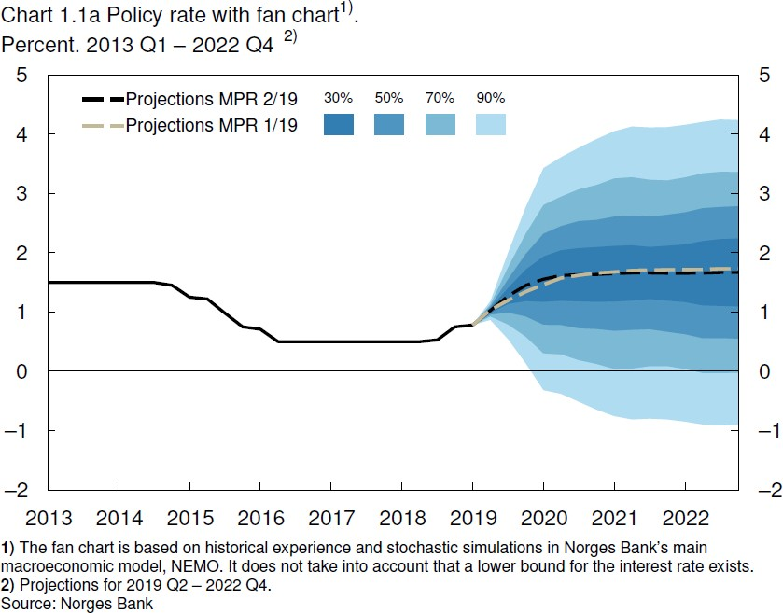

# Sweden

The chart below is from the Monetary Policy Report of July 2019 by the Riksbank.

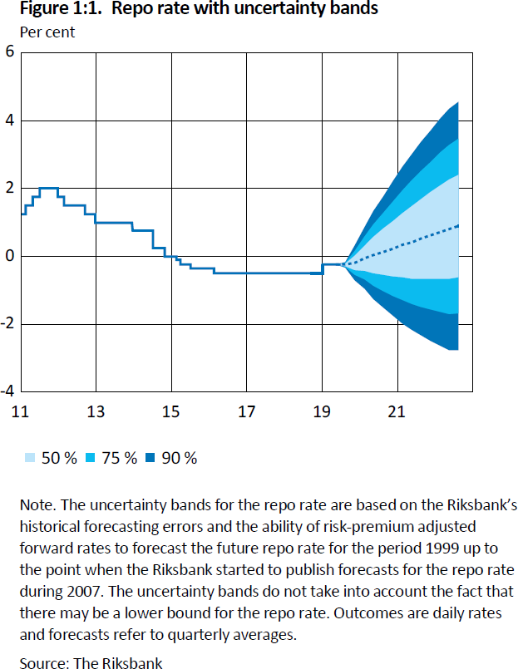

# US

The chart below is from the FOMS’s June 2019 meeting projection materials.

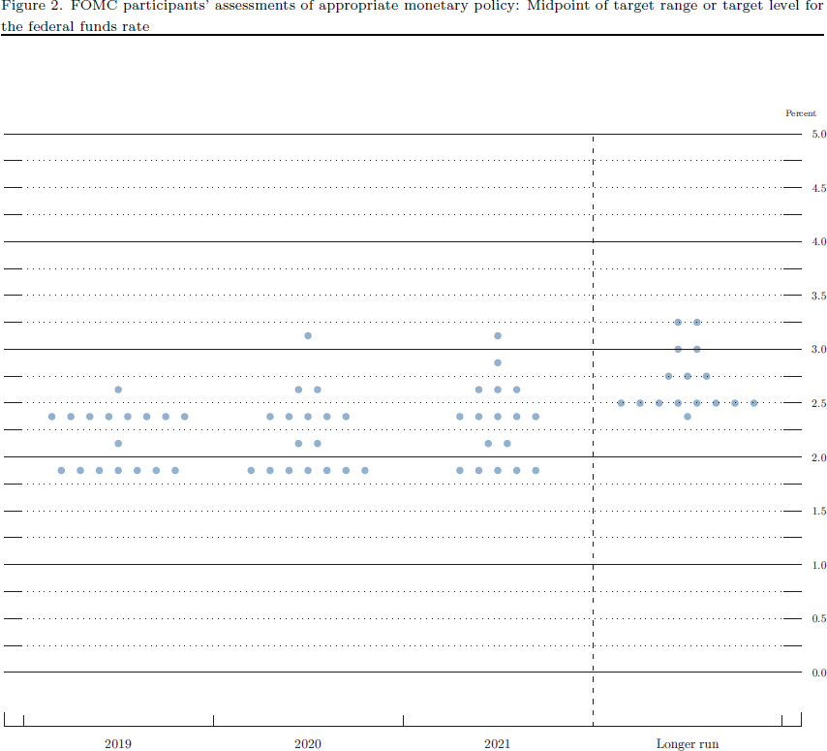

# New Zealand

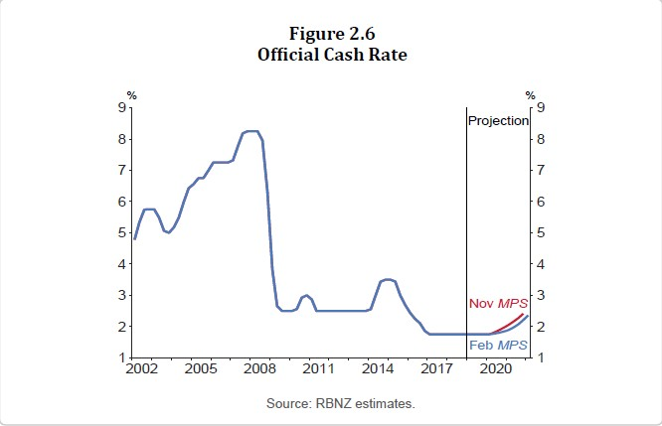The chart below is from the Monetary Policy Statement of February 2019 by the RBNZ.

# Czech Republic

The chart below is from the Inflation Report of May 2019 by the Czech National Bank.

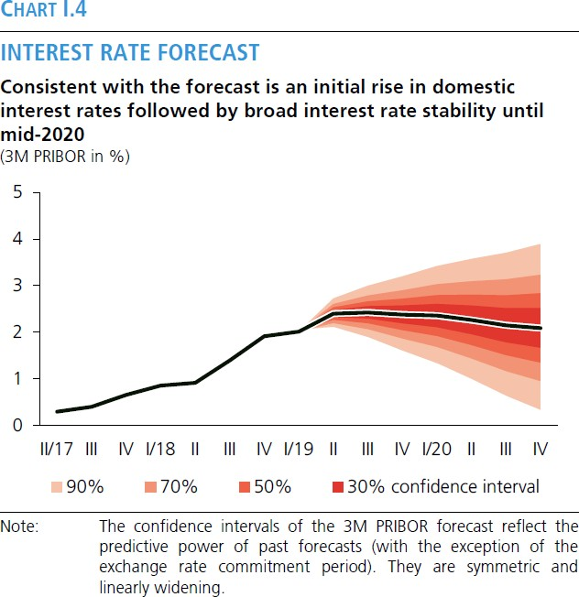

# Israel

The chart below is from the Bank of Israel Research Department Staff Forecast of April 2019.

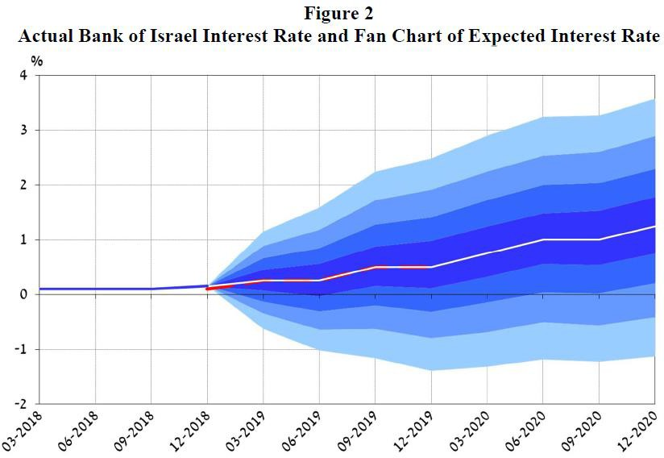

# South Africa

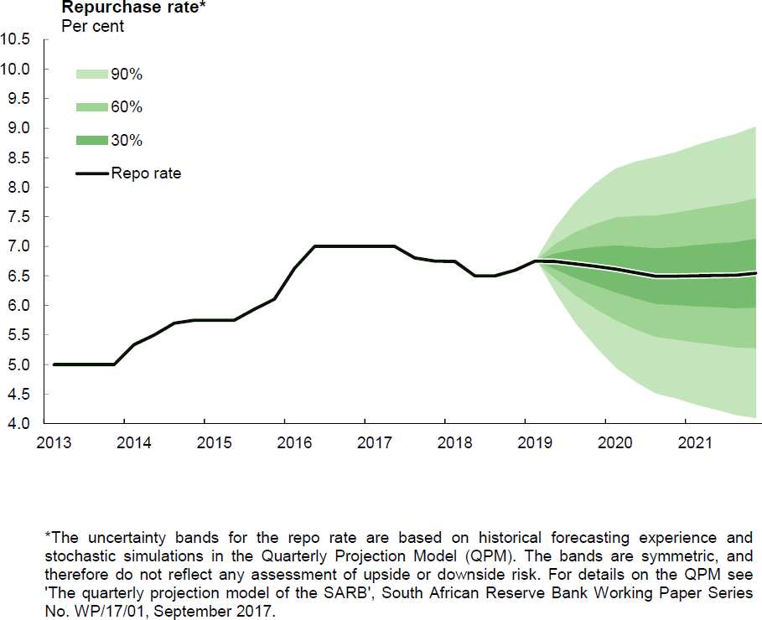The chart below is from May 2019 Statement of the Monetary Policy Committee by the South African Reserve Bank.